Practical : 4

## Aim : Design a web form to allow user to enter following details in his Resume using Web Server Controls. Set validations using properties. When data is submitted it must be viewed in the panel below the form. Fields of Resume are FirstName, Surname, Gender, Address, City, Pincode, Phone, Qualification (Diploma, Bachelor, Master), Specialization subject, Percentage.

Resume.aspx

<%@ Page Language="vb" AutoEventWireup="false" CodeBehind="Resume.aspx.vb" Inherits="Practical_4._Resume" %>

<!DOCTYPE html PUBLIC "-//W3C//DTD XHTML 1.0 Transitional//EN" "http://www.w3.org/TR/xhtml1/DTD/xhtml1-transitional.dtd">

<html xmlns="http://www.w3.org/1999/xhtml">

<head runat="server">

<title></title>

</head>

<body>

<form id="form1" runat="server">

<p>

First Name:

<asp:TextBox ID="txtFname" runat="server" MaxLength="15"></asp:TextBox>

</p>

<p>

<asp:Label ID="Label2" runat="server" Text="Surname : "></asp:Label>

<asp:TextBox ID="txtLname" runat="server"></asp:TextBox>

</p>

<p>

Gender: <asp:RadioButton ID="rdoMale" runat="server" GroupName="gender" Text="Male" />

<asp:RadioButton ID="rdoFemale" runat="server" GroupName="gender" Text="Female" />

</p>

<p>

Address: <asp:TextBox ID="txtAddress" runat="server" TextMode="MultiLine"/>

</p>

<p>

City:

<asp:DropDownList ID="drpCity" runat="server">

<asp:ListItem ID="drpListGandhinagar" runat="server">Gandhinagar</asp:ListItem>

<asp:ListItem ID="drpListAhmedabad" runat="server">Ahmedabad</asp:ListItem>

<asp:ListItem ID="drpListSurat" runat="server">Surat</asp:ListItem>

<asp:ListItem ID="drpListRajkot" runat="server">Rajkot</asp:ListItem>

</asp:DropDownList>

</p>

<p>

Pincode: <asp:TextBox ID="txtPincode" runat="server" />

</p>

<p>

Phone: <asp:TextBox ID="txtPhone" runat="server" MaxLength="10"

/>

</p>

<p>

Qualification: <asp:RadioButton ID="radDiploma" runat="server" GroupName="qualification" Text="Diploma"/>

<asp:RadioButton ID="radDegree" runat="server" GroupName="qualification" Text="Degree"/>

<asp:RadioButton ID="radMasters" runat="server" GroupName="qualification" Text="Masters"/>

</p>

<p>

Specialization Subject: <asp:TextBox ID="txtSpeSub" runat="server"/>

</p>

<p>

Percentage: <asp:TextBox ID="txtPercentage" runat="server" />

</p>

<p>

<asp:Button ID="submitButton" runat="server" Text="Submit" />

</p>

<asp:Panel ID="resultPanel" runat="server">

First Name : <asp:Label ID="lblFname" runat="server" Text="" />

<br />

Surname : <asp:Label ID="lblLName" runat="server" Text="" />

<br />

Gender: <asp:Label ID="lblGender" runat="server" Text="" />

<br />

Address :

<asp:Label ID="lblAddress" runat="server" Text="" />

<br />

City : <asp:Label ID="lblCity" runat="server" Text="" />

<br />

Pincode : <asp:Label ID="lblPincode" runat="server" Text="" />

<br />

Phone : <asp:Label ID="lblPhone" runat="server" Text="" />

<br />

Qualification :

<asp:Label ID="lblQualification" runat="server" Text=""></asp:Label>

<br />

Specialization Subject : <asp:Label ID="lblSpeSubject" runat="server" Text="" />

<br />

Percentage : <asp:Label ID="lblPercentage" runat="server" Text="" />

<br />

</asp:Panel>

</form>

</body>

</html>

Resume.aspx.vb

Public Class _Resume

Inherits System.Web.UI.Page

Protected Sub Page_Load(ByVal sender As Object, ByVal e As System.EventArgs) Handles Me.Load

resultPanel.Visible = False

End Sub

Protected Sub submitButton_Click(ByVal sender As Object, ByVal e As EventArgs) Handles submitButton.Click

resultPanel.Visible = "True"

lblFname.Text = txtFname.Text

lblLName.Text = txtLname.Text

If rdoMale.Checked = True Then

lblGender.Text = rdoMale.Text

Else

lblGender.Text = rdoFemale.Text

End If

lblAddress.Text = txtAddress.Text

lblCity.Text = drpCity.Text

lblPincode.Text = txtPincode.Text

lblPhone.Text = txtPhone.Text

If radDiploma.Checked = True Then

lblQualification.Text = "Diploma"

ElseIf radDegree.Checked = True Then

lblQualification.Text = "Degree"

Else

lblQualification.Text = "Masters"

End If

lblSpeSubject.Text = txtSpeSub.Text

lblPercentage.Text = txtPercentage.Text

End Sub

End Class

Result :

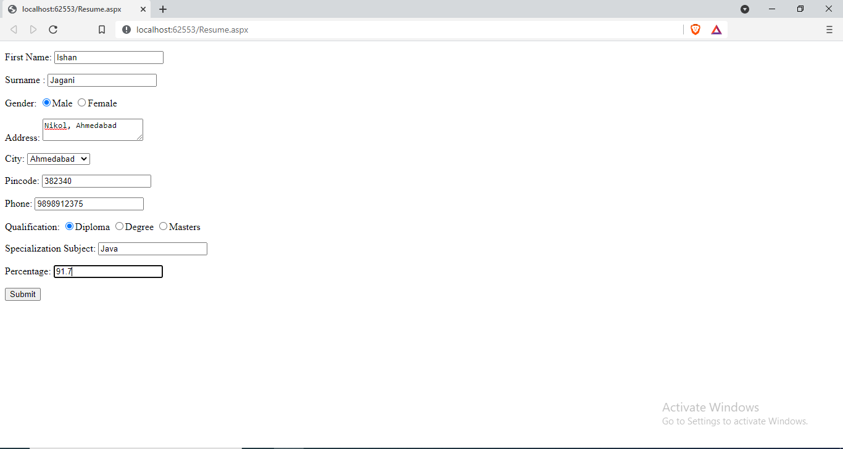

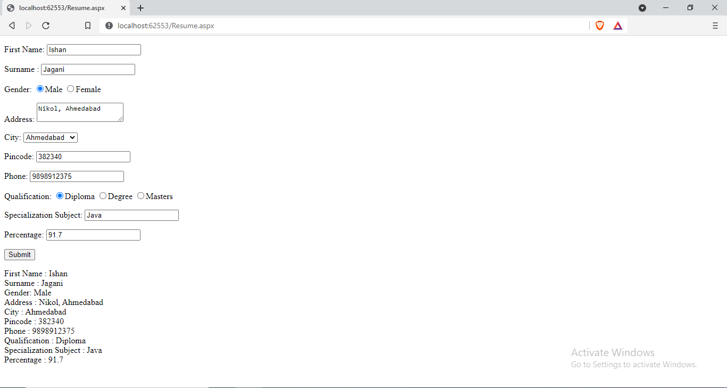

|  |  |  |  |
| --- | --- | --- | --- |
| Start Date | End/Sign Date | Faculty Sign | Remarks/Grade |
|  |  |  |  |

Practical : 5

## Aim : Create a web form where user enters following marks. ASP.NET, JAVA, ISS, Project (All out of 100). When user submits the marks, numeric value validation must be done. On entering marks, the grade should be displayed in message box .

Result.aspx

<%@ Page Language="vb" AutoEventWireup="false" CodeBehind="WebForm1.aspx.vb" Inherits="Practical_5.WebForm1" %>

<!DOCTYPE html PUBLIC "-//W3C//DTD XHTML 1.0 Transitional//EN" "http://www.w3.org/TR/xhtml1/DTD/xhtml1-transitional.dtd">

<html xmlns="http://www.w3.org/1999/xhtml">

<head runat="server">

<title></title>

<style type="text/css">

.style1

{

width: 302px;

}

</style>

</head>

<body>

<form id="marksheetForm" runat="server">

<div>

<table style="width:100%;">

<tr>

<td class="style1">

Asp.net </td>

<td>

<asp:TextBox ID="txtAsp" runat="server"></asp:TextBox>

</td>

<td>

<asp:Label ID="lblASP" runat="server" Text=""></asp:Label>

</td>

</tr>

<tr>

<td class="style1">

Java</td>

<td>

<asp:TextBox ID="txtJava" runat="server"></asp:TextBox>

</td>

<td>

<asp:Label ID="lblJava" runat="server" Text=""></asp:Label>

</td>

</tr>

<tr>

<td class="style1">

ICN</td>

<td>

<asp:TextBox ID="txtIcn" runat="server"></asp:TextBox>

</td>

<td>

<asp:Label ID="lblIcn" runat="server" Text=""></asp:Label>

</td>

</tr>

<tr>

<td class="style1">

ENS</td>

<td>

<asp:TextBox ID="txtEns" runat="server"></asp:TextBox>

</td>

<td>

<asp:Label ID="lblEns" runat="server" Text=""></asp:Label>

</td>

</tr>

<tr>

<td></td>

<td>

<asp:Button ID="viewResultBtn" runat="server" Text="Submit" Width="126px" />

</td>

<td></td>

</tr>

</table>

</div>

</form>

</body>

</html>

Result.aspx.vb

Public Class WebForm1

Inherits System.Web.UI.Page

Protected Sub Page_Load(ByVal sender As Object, ByVal e As System.EventArgs) Handles Me.Load

End Sub

Private Function getMyGrade(ByVal p1 As String) As String

If p1 > 90 And p1 <= 100 Then

Return "AA"

ElseIf p1 > 80 And p1 <= 90 Then

Return "AB"

ElseIf p1 > 70 And p1 <= 80 Then

Return "BB"

ElseIf p1 > 60 And p1 <= 70 Then

Return "BC"

ElseIf p1 > 50 And p1 <= 60 Then

Return "CC"

ElseIf p1 > 40 And p1 <= 50 Then

Return "DD"

Else

Return "Fail"

End If

End Function

Protected Sub viewResultBtn_Click(ByVal sender As Object, ByVal e As EventArgs) Handles viewResultBtn.Click

lblASP.Text = getMyGrade(txtAsp.Text)

lblJava.Text = getMyGrade(txtJava.Text)

lblIcn.Text = getMyGrade(txtIcn.Text)

lblEns.Text = getMyGrade(txtEns.Text)

End Sub

End Class

Result :

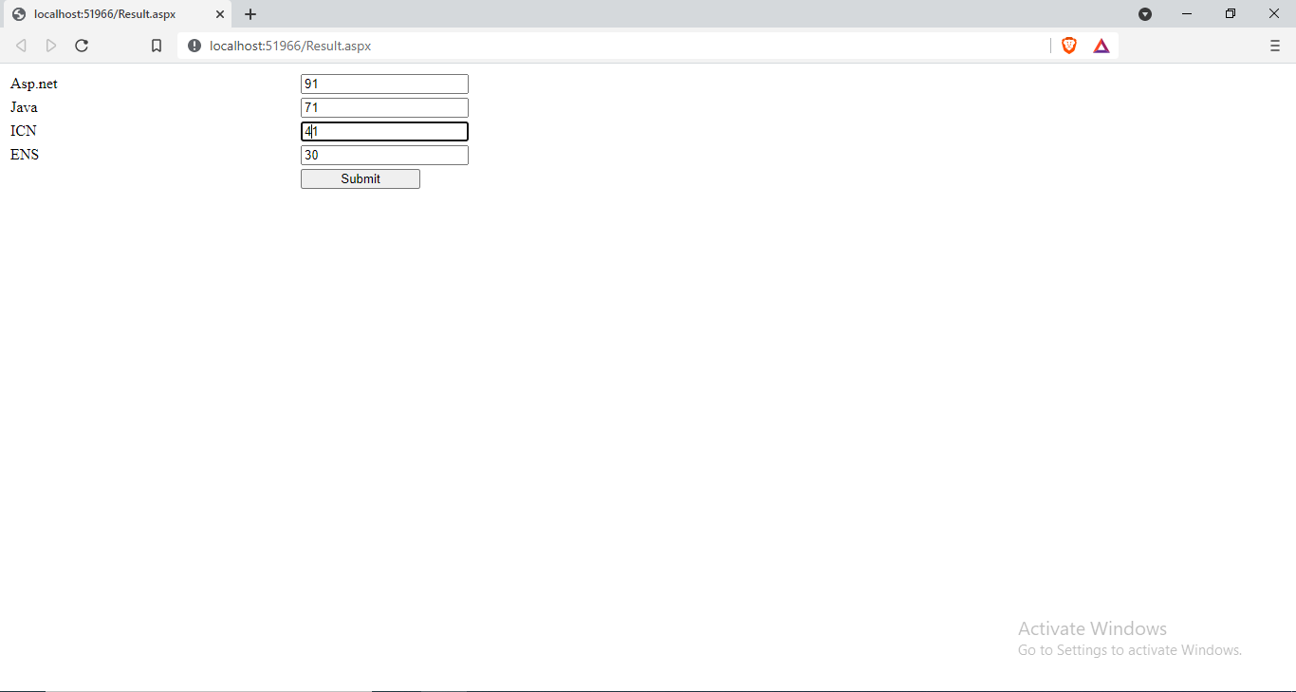

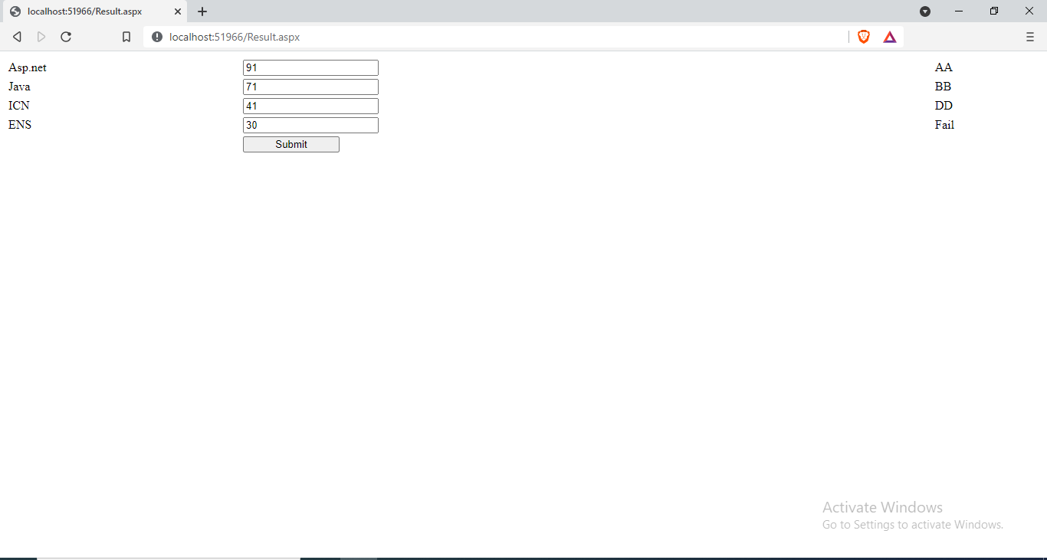

|  |  |  |  |
| --- | --- | --- | --- |
| Start Date | End/Sign Date | Faculty Sign | Remarks/Grade |
|  |  |  |  |